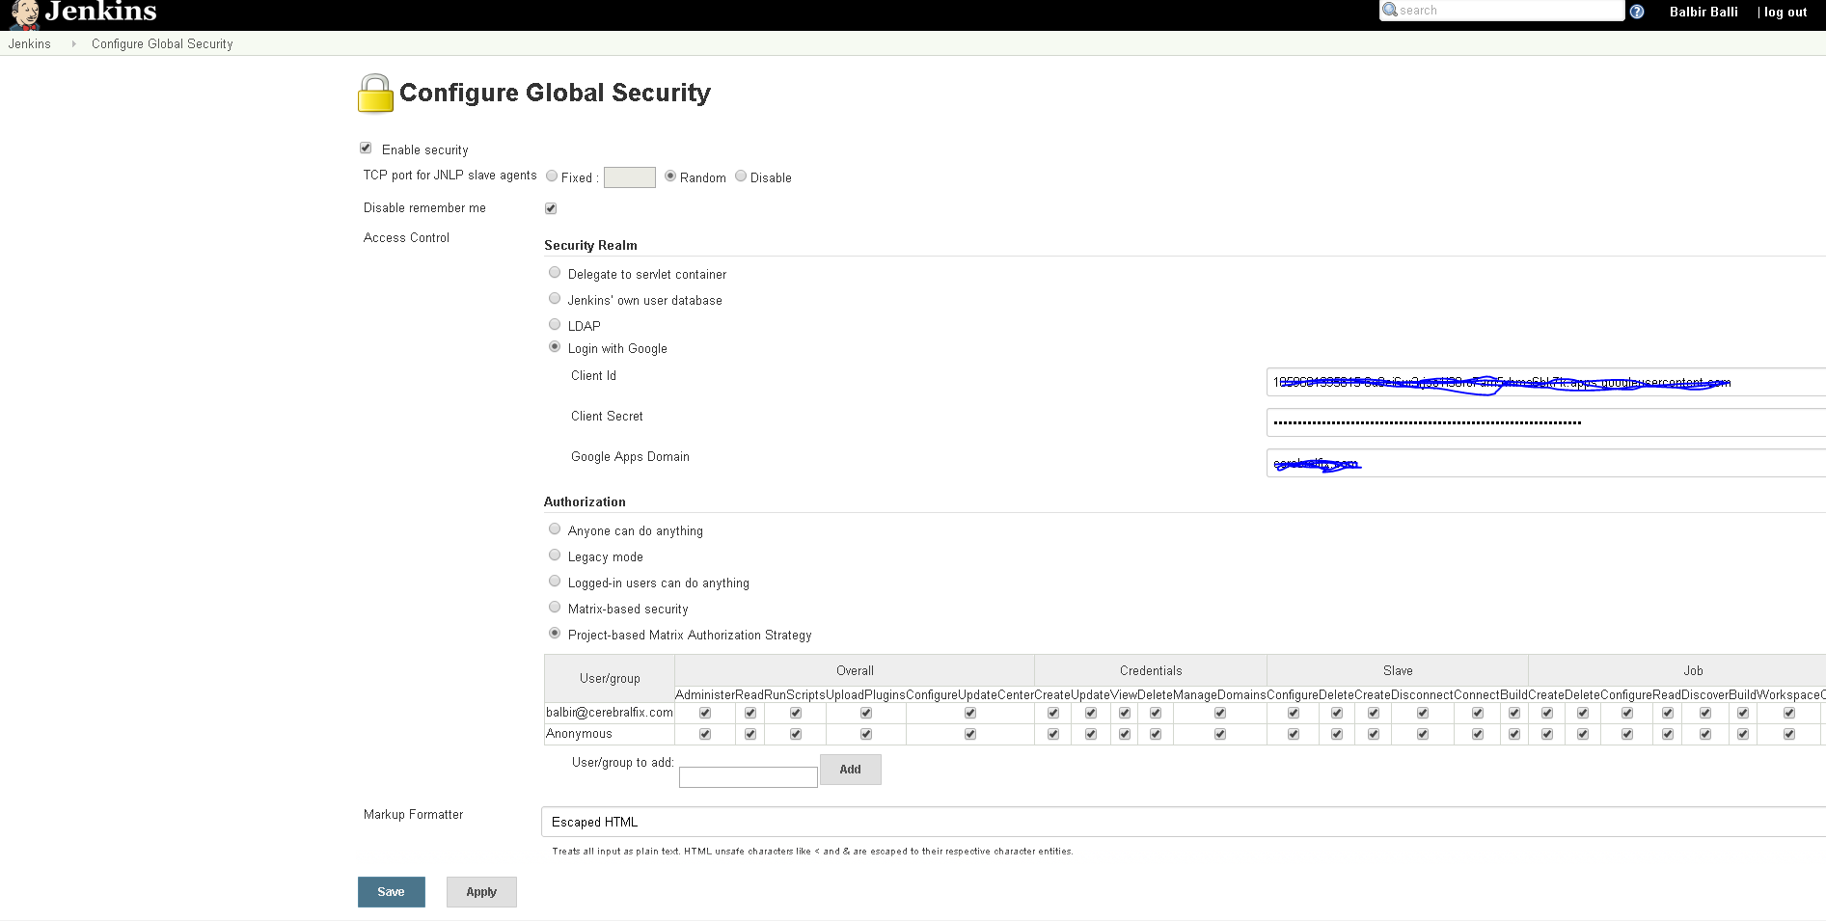

I am logged in as google user on above screen and selected Security Realm as “Login with Google” and Authorization as “Project-Based Matrix Authorization Strategy” or “Matrix-Based Security”.
Now log out I can see below that essentially means any one can do anything. I wanted to Utilize first screen combination for the security and assigning roles.
